Bahria University,

Karachi Campus



COURSE: CEN-221

COMPUTER ARCHITECTURE AND ORGANIZATION

TERM: FALL 2020, CLASS: BSE- 3(B)

Submitted By:

Raja Muhammad Hammad 81926

(Name) (Reg. No.)

Submitted To:

Engr. Ramsha Mashood/Engr. Noor us Sabah

Signed Remarks: Score:_____

INDEX

|  |  |  |  |  |
| --- | --- | --- | --- | --- |
| SNO | DATE | LAB NO | LAB OBJECTIVE | SIGN |
|  |  |  |  |  |
|  |  |  |  |  |
|  |  |  |  |  |
|  |  |  |  |  |
|  |  |  |  |  |
|  |  |  |  |  |
|  |  |  |  |  |
|  |  |  |  |  |
|  |  |  |  |  |
|  |  |  |  |  |
|  |  |  |  |  |
|  |  |  |  |  |
|  |  |  |  |  |
| SNO | DATE | LAB NO | LAB OBJECTIVE | SIGN |
|  |  |  |  |  |
|  |  |  |  |  |
|  |  |  |  |  |
|  |  |  |  |  |
|  |  |  |  |  |
|  |  |  |  |  |
|  |  |  |  |  |
|  |  |  |  |  |
|  |  |  |  |  |
|  |  |  |  |  |
|  |  |  |  |  |
|  |  |  |  |  |
|  |  |  |  |  |
|  |  |  |  |  |

Bahria University,

Karachi Campus



LAB EXPERIMENT NO.

**01**

LIST OF TASKS

|  |  |
| --- | --- |
| TASK NO | OBJECTIVE |
| 01 | Write the following tasks in VVM Assembly Language program as well as VVM Machine Language format: |
| Part A  Part B | 1. Take two inputs from the user and add them together, and then subtract the hardcoded value “5” from them. 2. Take three (any) hardcoded values and add them together. |
|  |  |
|  |  |

Submitted On:

**Date: 25/09/2023**

**Task No. 01:**

Write the following tasks in VVM Assembly Language program as well as VVM Machine Language format:

1. Take two inputs from the user and add them together, and then subtract the hardcoded value “5” from them.

**Solution:**

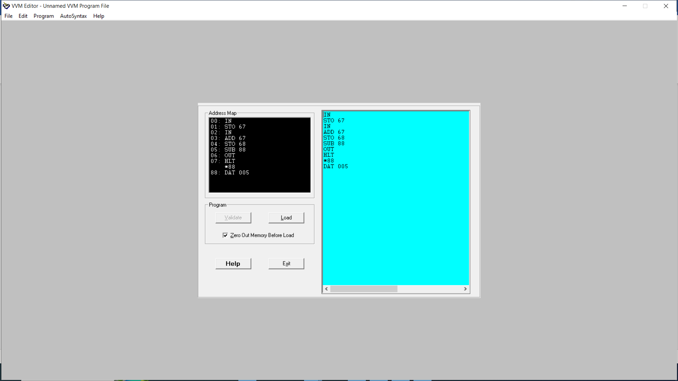

**Output:**

Figure Hardware View

Figure Trace View

1. Take three (any) hardcoded values and add them together.

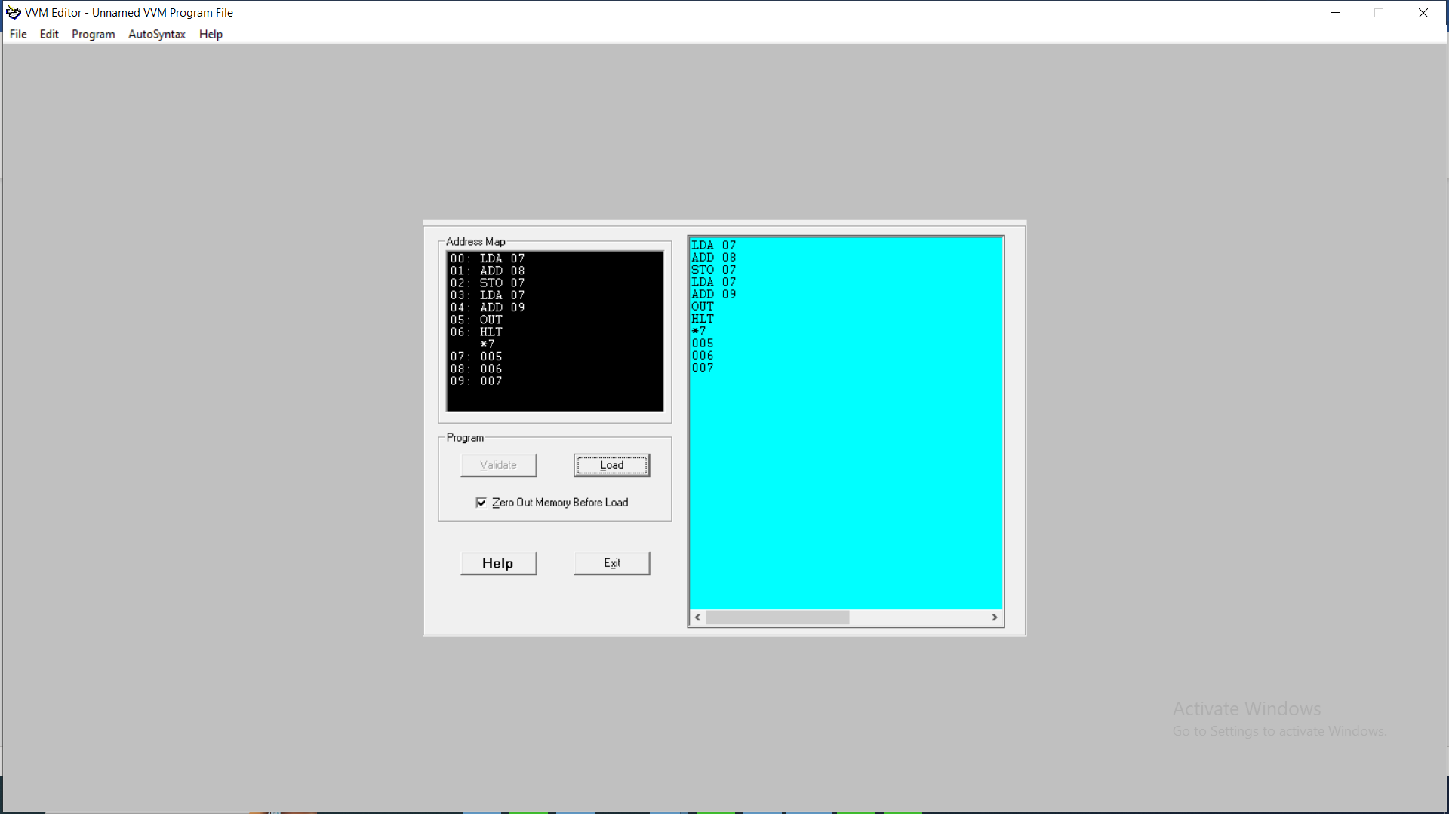 **Solution:**

**Output:**

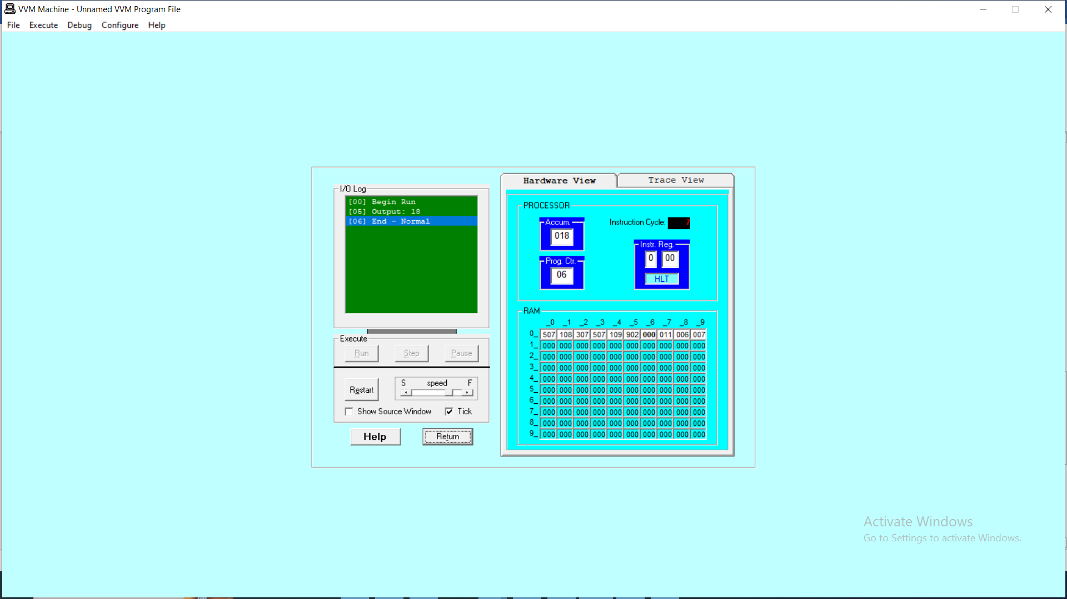Figure Hardware View

Figure Trace View

